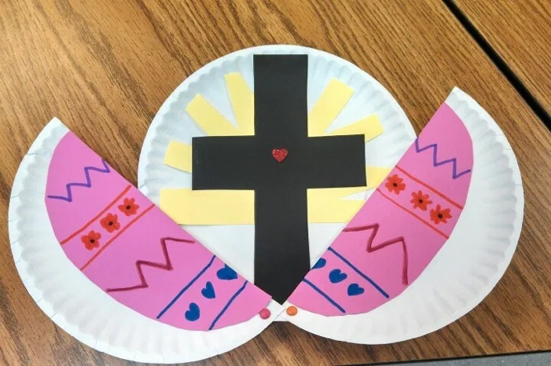
Easter Morning Cross

What you will need:
- 2 Paper Plates
- Black Paper
- Yellow Paper
- Coloured card for the egg
- 2 craft pins
- Coloured pens/pencils to decorate an easter egg
- Scissors
- Glue
What to do:
- Cut out sun beams from the yellow paper and glue them to the first plate. Cut out the cross from the black paper and glue it over the sun beams

- Draw and decorate an Easter egg and glue it on the front plate. Cut the plate down the middle. Attach with pins to the first plate so that it slides open.

As you open your Chocolate Eggs this Easter, remember that God gave His one and only Son Jesus, to die for us on the Cross at Calvary. Jesus was prepared to die for me and for you so that, one day we can be with Him in heaven.
Have a read of John C3 verse 16

