SGA Leadership Support SGA Badge Logo (Col Rev) July - Dec 2020

**MINISTRY REPORT FORM**

NAME……Stefan ZAREV

COUNTRY……BULGARIA……… CITY/TOWN or VILLAGE…Rakitovo………………..

CHURCH…Velingrad and Rakitovo Evangelical Churches.. MINISTRY (pastor/evangelist) a pastor.

We owe much gratefulness to those who continue to support us. In the pandemic 2020-21 the Lord is present and continues to work in us in order to walk straight in His path. He still desires for us to live for His glory as our supreme purpose. He has made us His children and there is nothing more valuable than that.

***Answers to prayer:***

Dear brothers, your prayers do matter. Let’s give thanks together to the Lord for His answers!

* We are thankful to God for His provision for two youth camps in July (for 3 days with our children’s friends from Sofia) and in August (a weekend with the youth group in Velingrad church). We had a nice time not because of the weather but because of the Bible talks and the easy to remember illustrations we could have on spiritual light and darkness in the mountain. The adventure was intensified with biking around the gorgeous lake and canoeing as well. Fun with friends and Bible wisdom is a good combination for lasting memories!

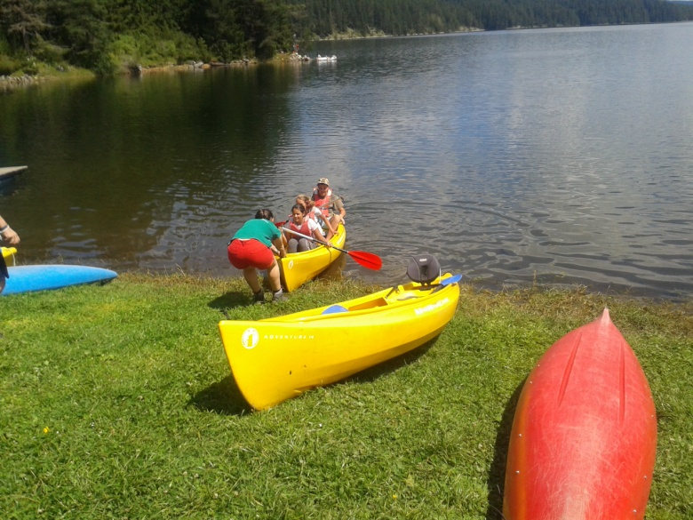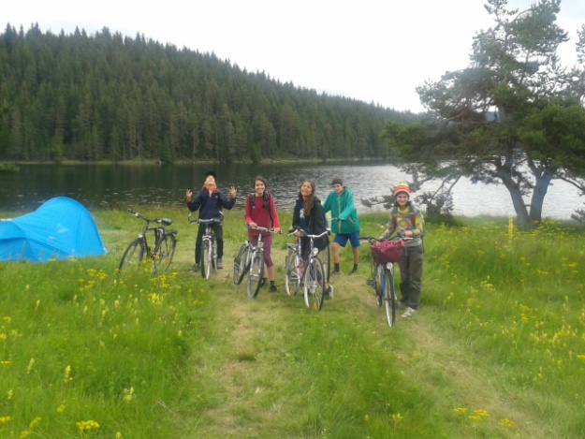

* God is merciful to us – all the people we know who had the Corona virus got well quickly, the other few with heavier cases recovered completely.
* In August the National Sports camp in Velingrad did happen. Due to the Corona crisis there were no Northern Irish, no German, no American Christians to lead and do the camp as it was the previous years. And God proved that Bulgarian youth leaders are able to organize the Sports event by themselves… successfully!
* The political tension had weakened. Bulgaria did not enter a political crisis, and all will have the chance to participate in the democratic process through their vote at the Parliamentary elections.
* 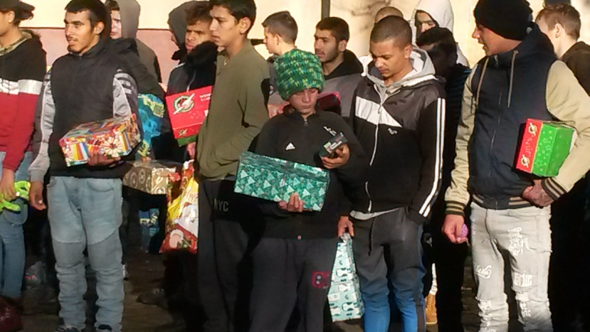Though in May and June the church meetings were renewed the online meetings for both Velingrad and Rakitovo communities of believers remained. Some people would have been left without Christian teaching and fellowship. These 30-40 minutes devoted for God’s Word and prayers are developing a closer connection among us.
* In November it turned out that the Christmas Child Operation would still be held in Bulgaria. Stefan went to the training in Sofia. Then he took the 400 shoe boxes the second week of December when the government had already closed the kindergartens and the schools. He distributed some gifts in the very season but most of them remained for January. God did bless this opportunity - the primary schools opened on 4 Jan 2021 and we can fulfill our mission to reach the needy kids with those gifts made with people’s love to show God’s love.

One boy at the Rakitovo Institution showed that he remembers in details the last year Christmas story Stefan had presented to them. These young souls need honest talks and special relationships that make difference in their lives.

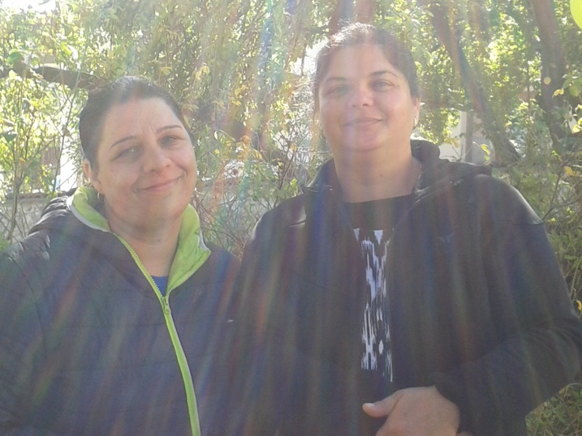Finally in October we met Mariana (left) and Jana in person! They are the ladies (we didn’t know) who since March 2020 listen and pray every Wednesday night at the online meeting. They live 80 km away from Velingrad. We had the great opportunity to meet their four children and introduce them to some believers their age as well as two local youth leaders. God is working in these families!

The most important plan is to prepare talks and all the logistics for more youth mountain events in the warm months.

***Family News:***

No matter when exactly our second daughter Boriana needs to graduate high school this spring with God’s help. We pray for God’s direction for her university major. Her desire and efforts are in becoming a nurse. So she is the second of our children who hopefully is going to study in Sofia.

After the four years Stefan’s mother lives with our family we need your prayers for patience and wisdom how to take care of her every day.

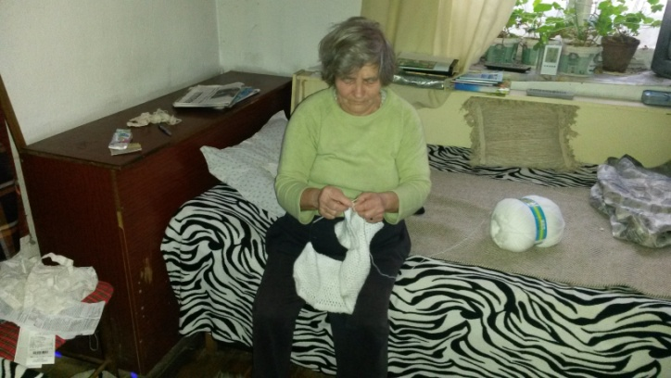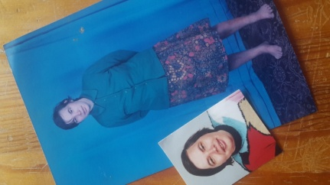

A Story we would like to share with you.

Her name is Violeta. She is not talkative. This small lady in her 70-ies became a unifying factor for the Rakitovo believers. In 2019 her life became unbearable. Some days her life was threatened. Her life was in danger after she had gone through the breast cancer 10 years ago and after she had been a widow for 3 years. The danger was due neither by sickness, nor by men. It was by her own child. Snejka was one of her three children. She showed symptoms of a mental disability when she was 6. Violeta’s husband insisted for Snejka to be given to a specialized institution. It was still in the communism period and with a heavy heart the mother gave her little girl.

The next days she was desperate and couldn’t think of anything else besides Snejka. Violeta could not stand anymore and got on the bus for the 40 km distance to the institution. Snejka was standing on the fence, crying and wearing the same clothes she was left with two weeks ago. Right there her mother decided to take Snejka back and never leave her again. And she took care of her for more than 40 years in poverty and in sickness.

Violeta works hard - doing every heavy job. She works well– silent and fast. She is a creative worker – knitting, sewing, crocheting, weaving, baking wonderful items. And all alongside she was taking care of her Snejka who grew big though stayed mentally small all these years.

For years, the selfless mother was going to the Orthodox church, lighting candle after candle. In 2002 she came to our Evangelical church invited by a neighbour. The first thing she understood was that Jesus Christ is the Son of God and the Lord. Sometimes the quiet faith is so strong. Her commitment to the Lord and the church are obvious for everyone. It seems Snejka respected her father more and was obedient to him. After his death she developed an aggression towards her committed Mom. It was getting harder and harder for Violeta to cope with the everyday cares about her daughter. She is no complainer, but the daughter’s violence and behaviour became harder.

The church started to pray regularly for the problem believing God has a way. We saw how exhausted she was and that she was suffering. It was evident Violeta could not do it by herself anymore. Her health and life were threatened. Beside material provisions we could not help more because Snejka got even more aggressive to strangers. After long internal fights Violeta saw her need to take Snejka to a Disabled People Institution. And she applied.

Some very long months passed by in waiting. A whole year went by. “There are no vacant places” the town Social agency always answered her. A lady from the church went with Violeta to help her apply again. She showed the church is beside Violeta’s case and would pursuit the procedure up to the end. We encouraged and prayed for her on and on. In January 2020 God intervened and Snejka was accepted in a facility for mentally disabled.

We thanked the Lord for that. Violeta was beginning to feel not so sad about her Snejka. Two months later the phone rang – Snejka had died. Did we make a mistake? Why did it happen? The mourning mother said: “I know Jesus is Lord over all – I trust Him!”

We live in the mountains. It is winter now. It is -15° outside freezing. We know that winter is the season when the forest grows slower. At this season, the trees get healthier and stronger preparing for the fast growth during summer. I wonder whether we are in the spiritual winter season now. I wonder whether the church is in the season when it grows slower meanwhile becoming stronger in the Lord.

Jesus Christ is Lord. “All things are made through Him and without him was not anything made that was made.” (John 1:3)

Stefan and Mira