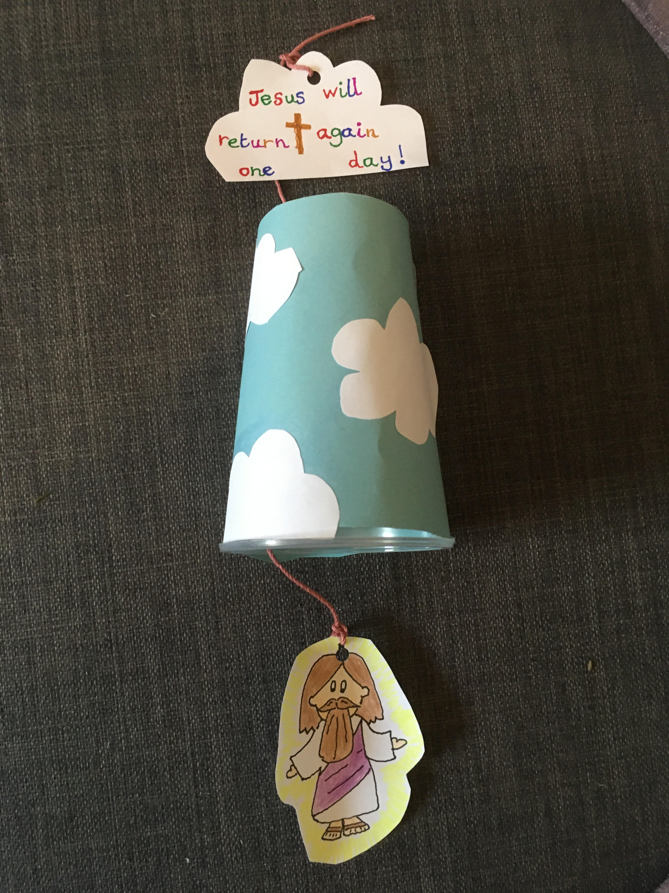
How to make an Ascension Craft
You will need:
- Paper cup: either paint it blue or cover it with blue paper
- White paper cut into cloud shapes(one cloud shape should be bigger than the others)
- Glue
- Scissors
- Colouring crayons/pens
- Pencil
- 30cm piece of either ribbon, string or wool
- Template of Jesus (see below)
How to make your Ascension Craft:
- Either paint your paper cup blue or cover it with blue paper (the cup will represent the sky)
- Take the white paper and cut out some cloud shapes. Cut out one larger cloud shape and put to one side
- Glue the smaller clouds to your paper cup
- Colour the template of Jesus and then carefully cut him out leaving a space above Jesus’ head
- Make a small hole in the top of the template where you have left a space
Template: Colour and cut out 1
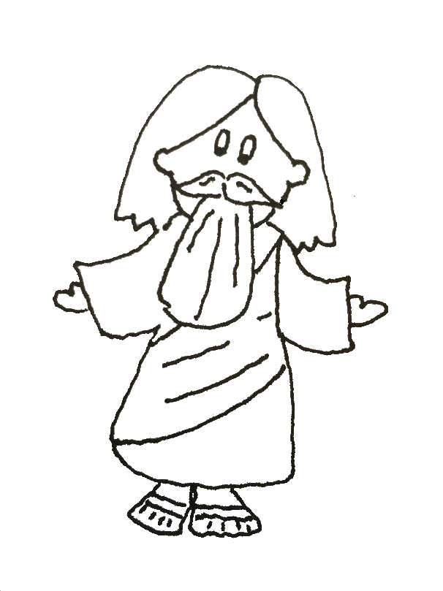
- Carefully thread your ribbon/string or wool through this hole and tie a secure knot
- Make a hole in the base of the blue cup using a pencil (Ask an adult to help if this is tricky)
- Thread the ribbon/string or wool through this hole
- On your larger cloud shape, write ‘Jesus will return one day’ and then glue this cloud to the ribbon/string or wool (see picture)
- Your craft is complete and you can now watch Jesus ascend to heaven when you pull the ribbon/string or wool
Reflection: ‘Don’t be sad, the angels declared. One day, Jesus will come back, just as you have seen him go’ What an amazing promise!

